5 Minutes to Calm:

A Yoga Sequence to include in your O&M Class
Objectives:
- Student will increase understanding of directional concepts up/down and lateral concepts left/right.
- Student will practice balance postures in a functional routine.
- Student will feel calm and grounded.

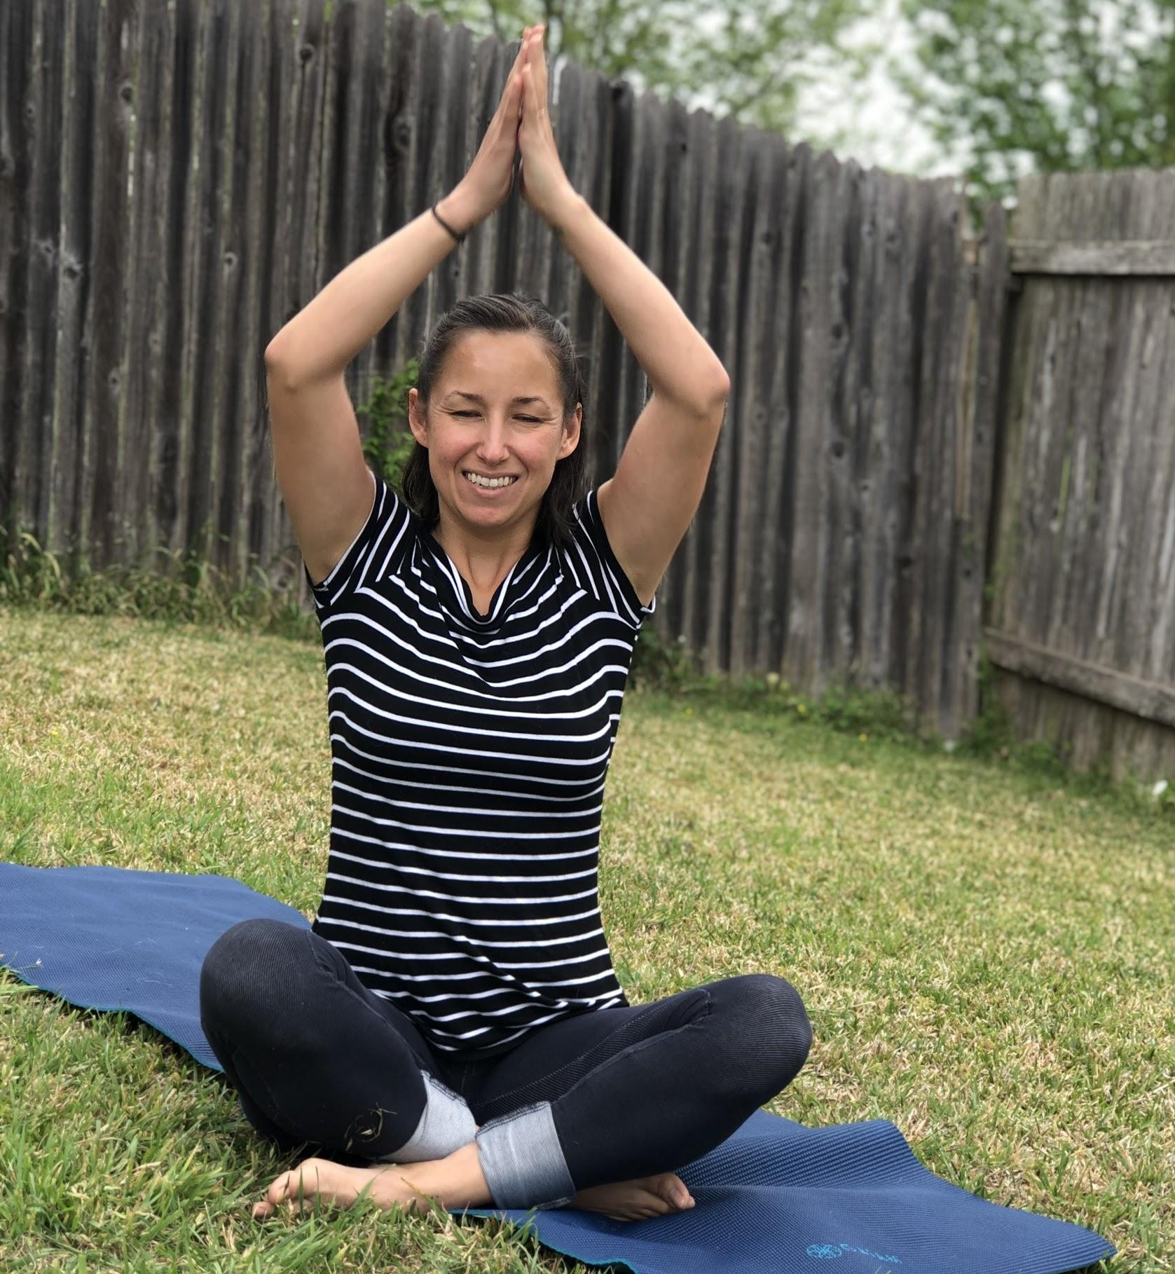
Tune In: Sunshine Breath (3-5x)
- From seated, breathe in and bring your arms out to the side. Lift your arms up to the sky and clasp them together!
- Breathe out and bring your hands down in front of your face, down
to your chest.
- (repeat 3-5 times)
____________________________________________________________________________
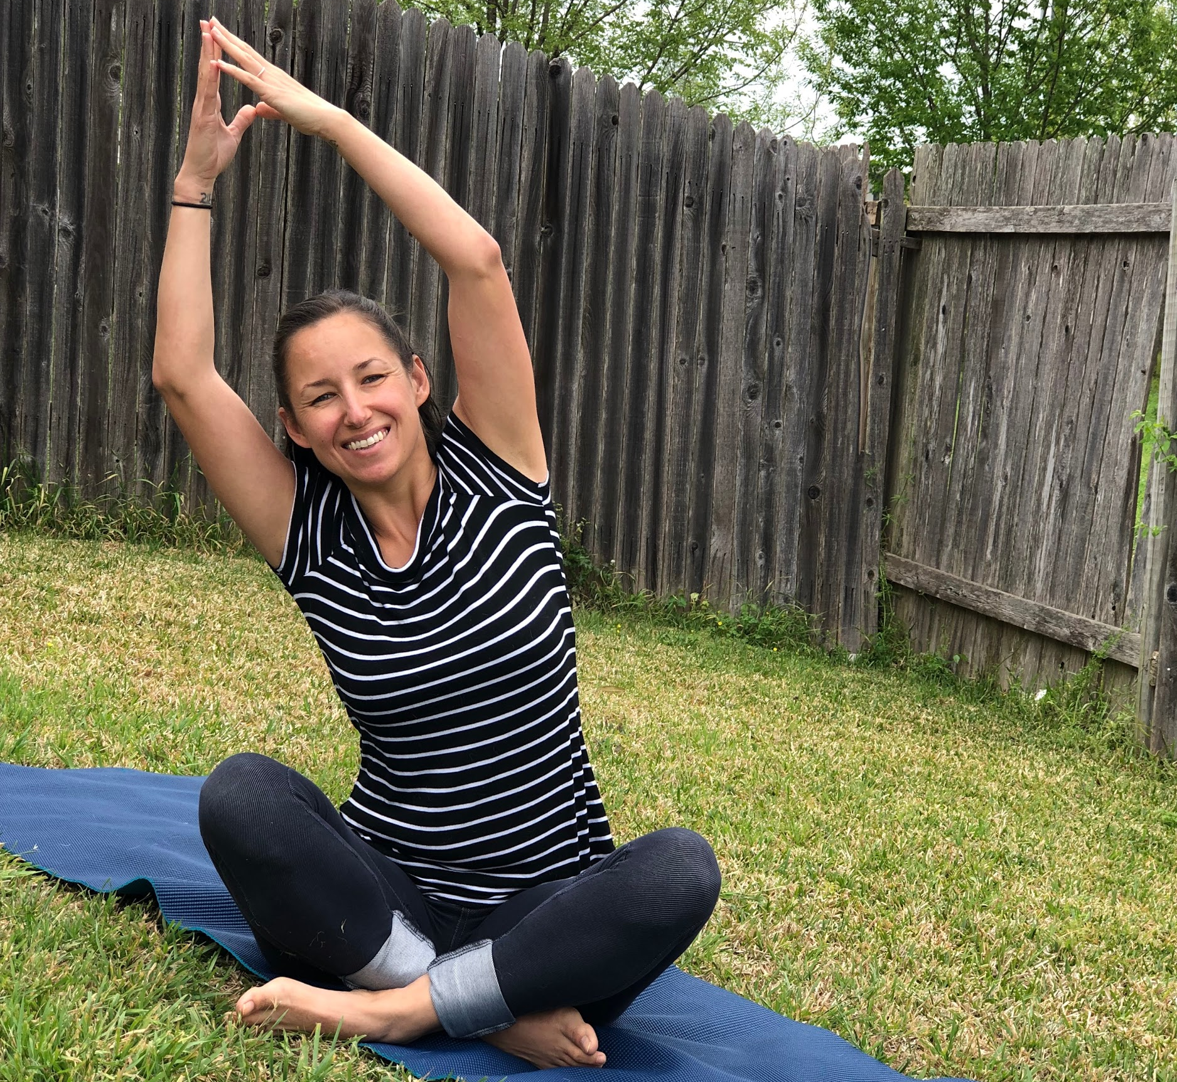
Movements:
- Seated Moon (3 breaths each side)
  - From seated, lift your arms up to the sky!
  - Clasp your hands together at the top and lean to the right. (hold for 3 breaths)
  - Now lean to the left.
(hold for 3 breaths)
____________________________________________________________________________
- Seated Twist (3 breaths each side)
  - From seated, lift your right arm up high in the sky!
Put it on the ground behind you, plop!
  - Lift your left arm and put it on your right knee. Plop!
  - Twist to the right! (hold 3 breaths)
  - Come back to center. (Complete on the left side)
____________________________________________________________________________
- Cat/Cow (3x)
  - Come in to All Fours. Put your hands underneath your shoulders, elbows straight. Put your knees under your hips.
  - Arch your back and look up. “Moo!” You’re a Cow!
  - Round your back and look down. “Meeoow!”, You’re a Cat! (Repeat 3x)
____________________________________________________________________________

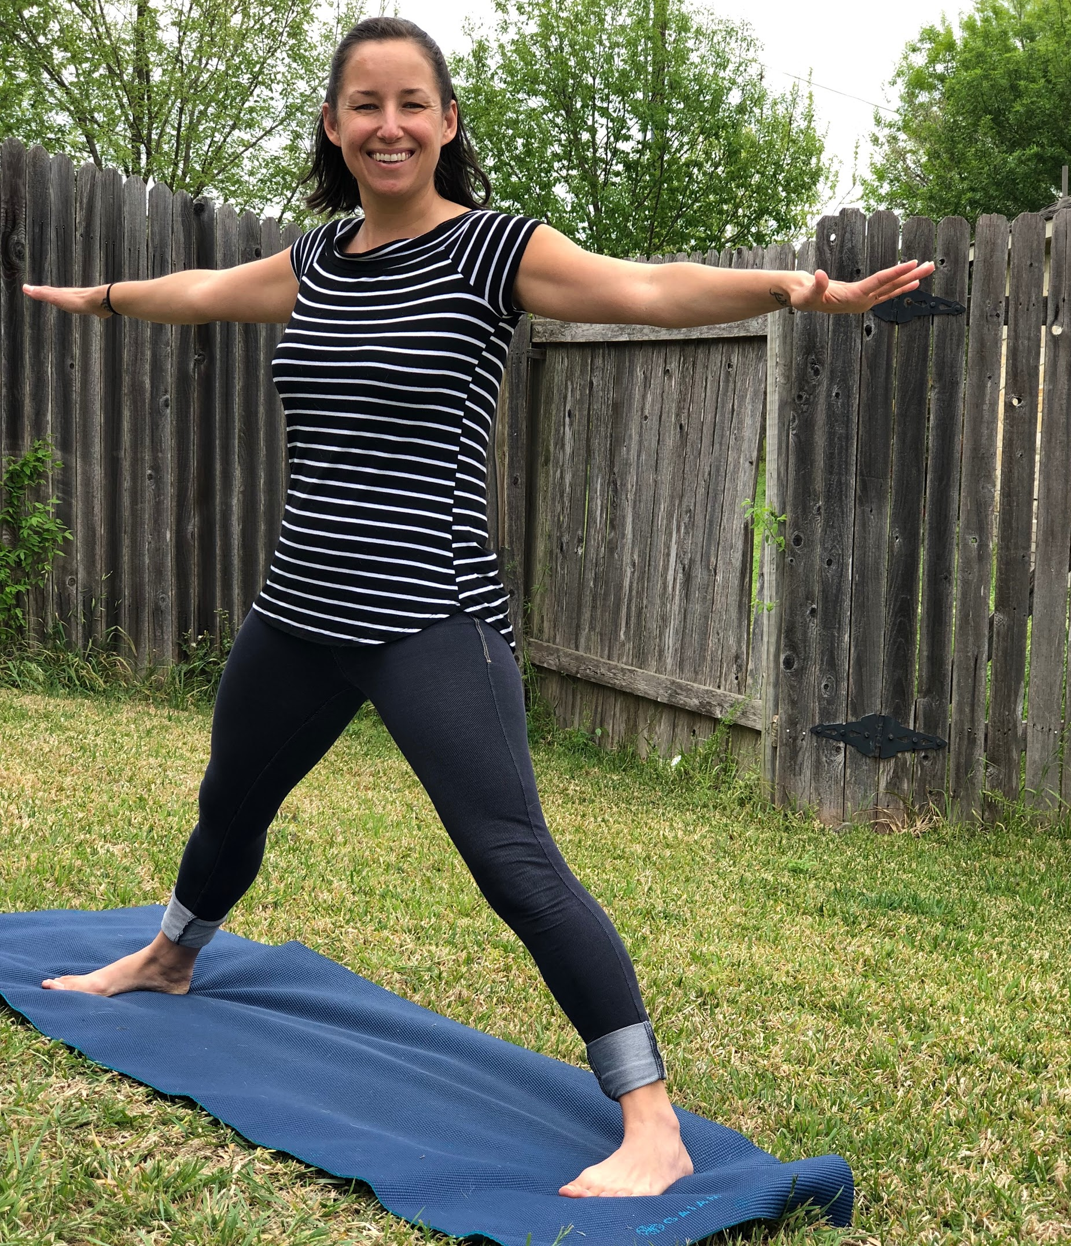
- Star (3 breaths each side)
  - It’s time to stand up! Turn to the long side of your mat.
  - Walk your feet wide to the left and right.
(Make sure their feet are facing forward).
  - Straighten your arms out to the side!
  - Lean to the left. (hold for 3 breaths).
(Repeat on the right side).
____________________________________________________________________________
- Wide Legged Forward Fold (3-5 breaths)
  - From Star Pose, lean down and bring your hands towards the ground.
(Make sure their knees are not locked out).

____________________________________________________________________________
- Cat/Cow (3x) or Sunbird (raise each arm for 3 breaths)
For Cat/Cow, repeat instructions above. For Sunbird:
  - From hands and knees, Lift your right arm up to your ear,
parallel with the ground. (hold for 3 breaths)
Repeat on left side. Can repeat for each leg as well.

____________________________________________________________________________
- Child’s Pose (3-5 breaths)
  - From All Fours, sit your hips on to your heels.
  - Relax your head down to the ground.
(Can have their arms out in front, or behind. Can keep knees wide and toes together or keep knees and feet parallel).
____________________________________________________________________________

Relaxation: Quiet breathing for 10 breaths
For a full yoga class, relaxation is typically done laying down on the back. For a Yoga Break such as this sequence, relaxation can be simply taking 10 deep breaths.

Valediction: Good job and GoodBye!
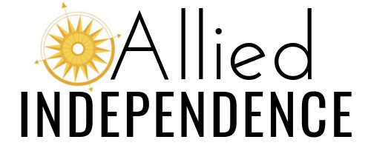
More information can be found at:
- Allied Independence Online.com
- Sequence Selection

What is yoga?
- For our purposes, yoga is a practice of simple movements that incorporates breathing to provide a safe and fun form of exercise!
- For us, yoga is NOT religious or spiritual.

Why practice yoga and movement activities at home?
- Yoga and movement activities are Safe, Fun, and Effective!
- Increases rec/leisure skills (by practicing exercises)
- Increases self-determination (by doing exercise at least once/week for 12 weeks)
- Increases body and spatial awareness (by identifying body parts and pairing movements in a fun, motivating activity).
- Increases leadership skills (have the student show you the poses once they know them, or have them choose the poses they want to do).

Yoga Sequences We Might Have Practiced in Class:
Animal Adventure Yoga Sequence
5 Minutes to Calm Yoga Sequence

What should I practice?

Age: | Length of Time: | Objective: | Videos:
0-3 | 5-10 minutes, baby on or around parent. | Increase movement.  Bonding.  Have fun! | Mommy & Me Yoga, Kassy Maloney  Game: Going on a Bear Hunt, Kassy Maloney
3-5 | 5-10 minutes, child performing moves | Increase movement.  Increase spatial awareness.  Fun activity! | Silly Animal Yoga, Kassy Maloney  Mommy & Me Yoga, Kassy Maloney  Cosmic Kids Yoga, YouTube Channel
6-12 | 10-25 minutes | Increase movement & spatial awareness.  Increase leadership skills.  Fun activity! | Silly Animal Yoga, Kassy Maloney  Cosmic Kids Yoga, YouTube Channel  Games: Yoga Story-Have them write a story using animal poses, then practice the sequence.  Pick a Pose: Create cards that have yoga poses written or Brailled on them. Have the child pick a card and practice the poses.
12-18+ | 5 minutes for a yoga break, or up to 45 minutes. | Increase exercise and rec/leisure.  Improve movement abilities. | Yoga for Teens, Yoga with Adrienne  Yoga for Teens, Wanderlust

RESOURCES:
Music: Children’s Yoga & Meditation Songs, Shakta Kaur Khalsa
Music from “Happy” & “Cozy” CD’s on a YouTube Playlist, Shakta Kaur Khalsa
Karma Kids Yoga, YouTube Playlist
Go Noodle, on YouTube

